We have six graphs per case (the original four plus two new ones).

The first is dynamic fluence, interpolated apertures.

The second is dynamic fluence, interpolated apertures, original Dij.

The third is the same as the second, but with the reference dose equal to dynamic fluence, interpolated apertures, original Dij at 0.5 degree resolution. Therefore we are comparing a single calculation method to itself as we increase the resolution.

The fourth is static fluence, original apertures.

The firth is static fluence, original apertures, but with the reference dose equal to static fluence, original apertures at 0.5 degree resolution. Similar to third graph.

The sixth is static fluence, interpolated apertures.

**TG119**

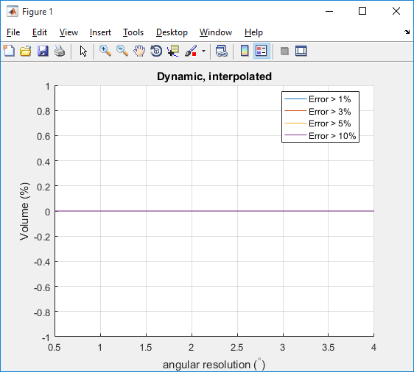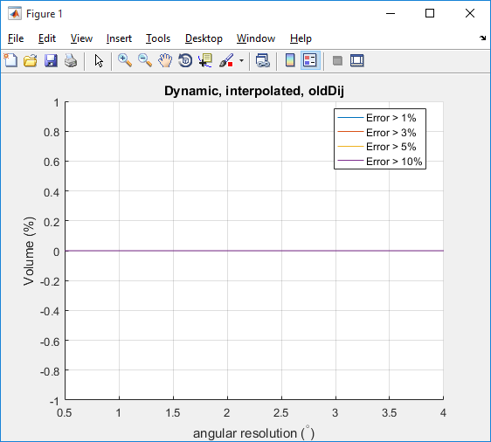

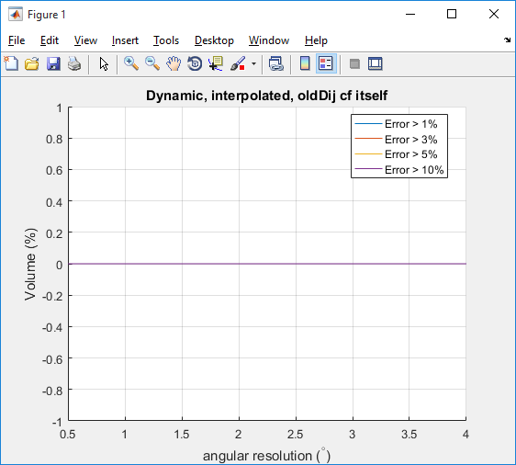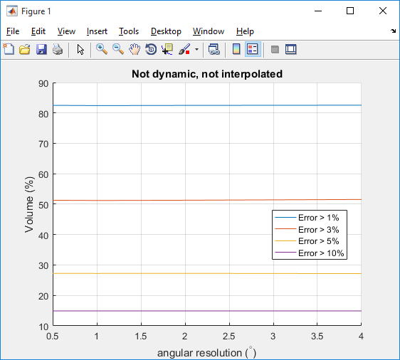

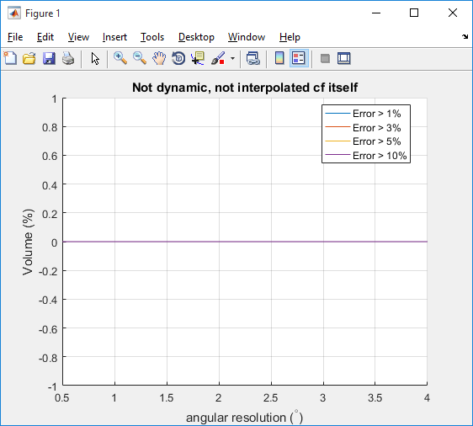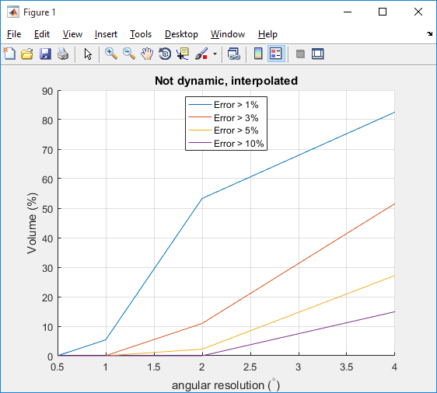

Dynamic interpolated is flat across the board for TG119, indicating that even at 4 degrees the dose is accurate.

**Prostate**

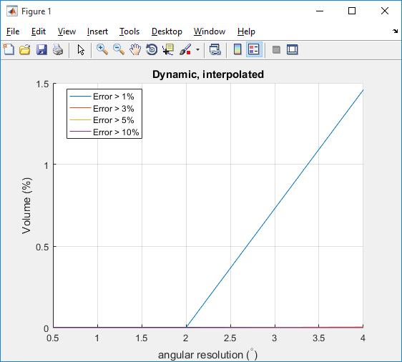 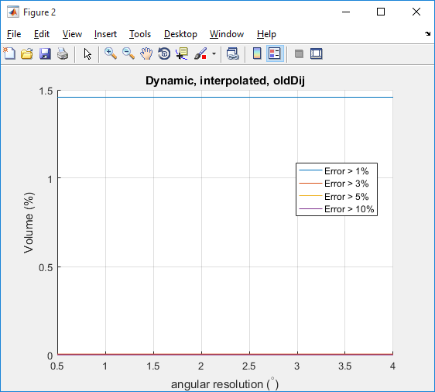

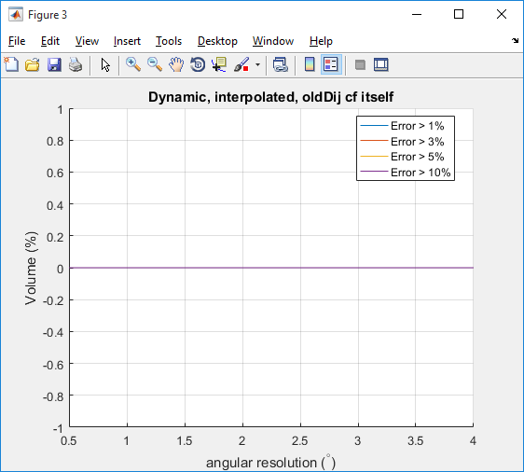 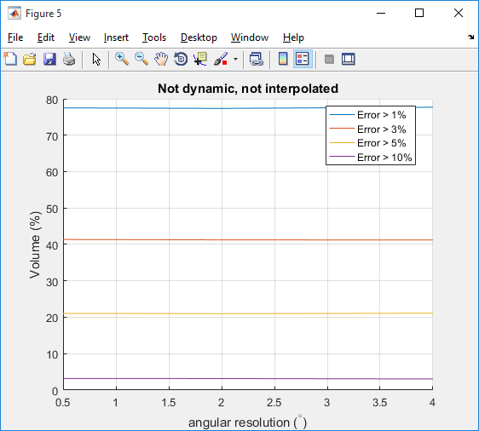 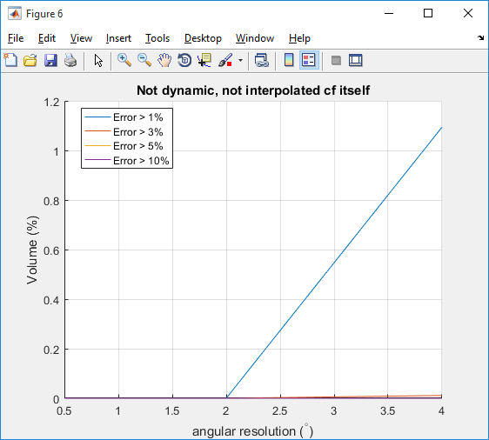 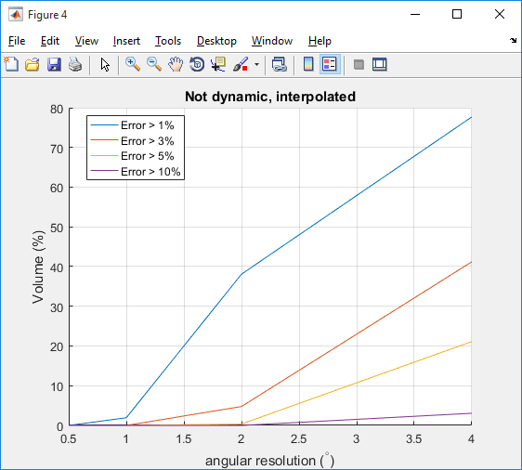

Here is where things get more interesting. If we compare the dynamic, original Dij calculations to itself, there is still no change, indicating that the fluence does indeed not change when resolution is increased (this is good).

However, if we compare static, original apertures to itself, we see that the Dij matrices do indeed have an effect on the percent of voxels having a greater than 1%. The percentage of voxels is on the order of the percent that we see in Figure 1 (dynamic, interpolated apertures). This indicates that it is likely that the 2% voxel discrepancy is coming from the Dij matrices.

**Head and neck**

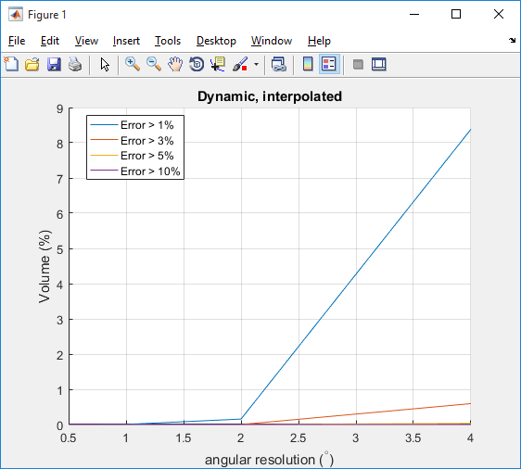 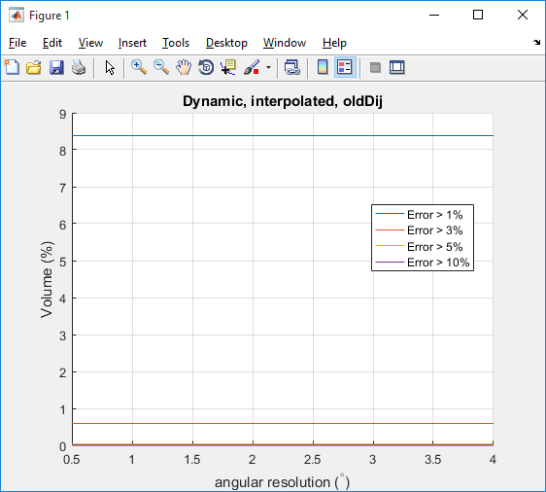

 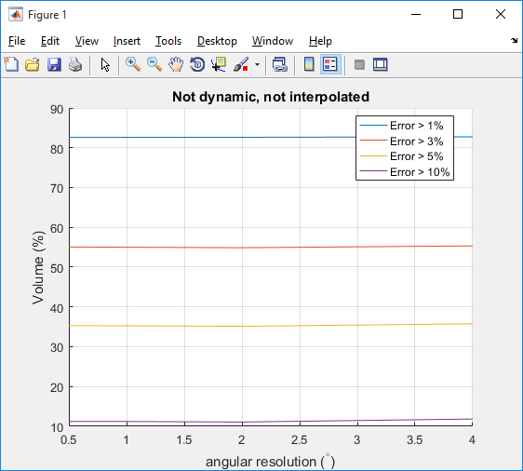

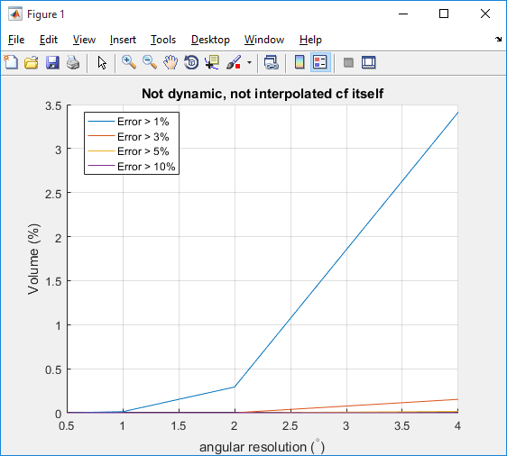 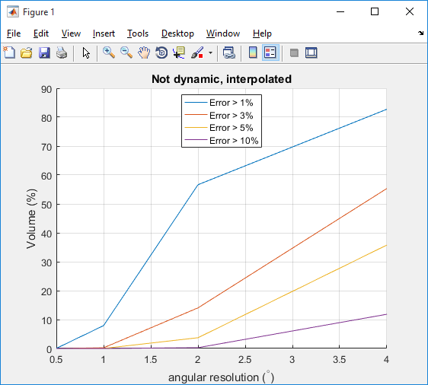

For head and neck, we have to go down to 2 degree resolution to get similar agreement as the prostate case (4 degree resolution).

**Thoughts**

I think these results were hidden in the original figures we were looking at because we’re only looking at the number of voxels with an error greater than a certain amount (say, 1%). We know already that the Dij matrix doesn’t change *that* much for any of the cases (worst case is in the head and neck case). The static, original aperture figure is supposed to tell us the variation of the dose as we increase the Dij resolution, by comparing the dose to our reference dose (dynamic @ 0.5 degree). We already see a huge number of voxels with a >1% error at 4 degrees. It is likely that doses do not change enough when increasing the Dij angular resolution to see any difference in this graph. Only when we compare the static original aperture calculation to itself can we see the difference.

I am starting to think that these metrics are not the most appropriate for what we are looking at. We are interested in how the dose itself changes when we increase the resolution/change calculation methods. I think that we should be looking at the dose difference directly, instead of the number of voxels having a dose difference greater than a certain threshold. What do you think?

(By the way Emily, I will re-run the dose calculation scripts using the larger lateral cutoff of 82 mm instead of 25 mm. In the new update, the default cutoff was increased from 25 mm to 82 mm, which I switched back to in order to save memory. Since we don’t keep Dij in memory, this is not a concern, although it will probably increase the calculation time).